# Answer sheet Processing lab 2

Instructions: Fill out your answers below. Make a PDF of the complete file, and upload that **PDF** on Blackboard.

Student 1 (Full name & student number): Vito Vekic (1091719)

Student 2 (Full name & student number): Sterre van Strien (6138942)

## **Assignment 1 Response Amplitudes**

**1A (figure)**

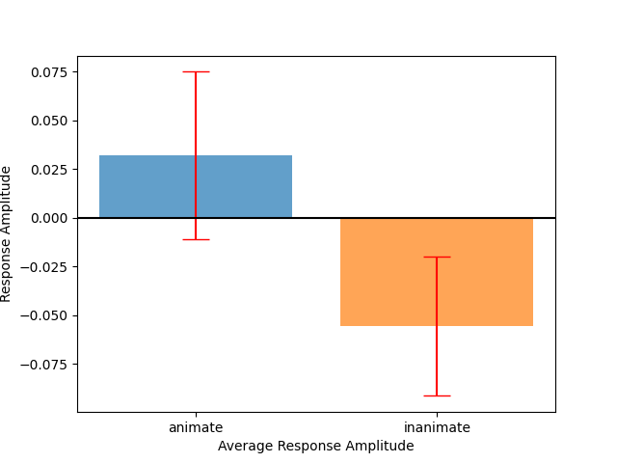

**1B:** T-value: 1.619844 and P-value: 0.05629. There is a significant difference, as P-value is bigger than 0.05.

**1C (figure):** 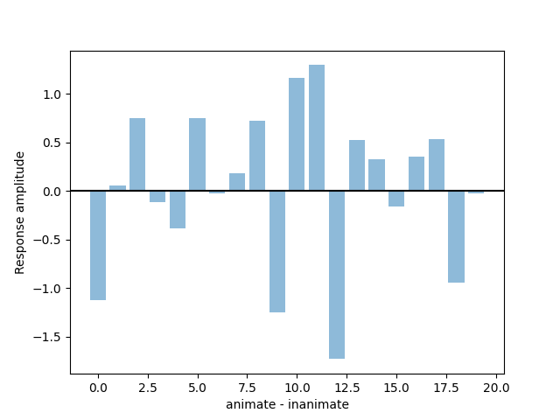

**1D:**

Some voxels may show positive value, and some may show a negative value because the average response to animate and inanimate objects may differ in different regions of the brain. If the overall mean for animate objects is higher than the overall mean for inanimate objects, it suggests that the brain activity for animate objects is generally higher than for inanimate objects across the entire brain. However, the individual voxel values may still show positive and negative values, indicating that the difference between animate and inanimate objects is not uniform across all voxels. This suggests that the difference between animate and inanimate objects may be more pronounced in some brain regions than others.

## **Assignment 2 Support Vector Machines**

**2A:**  The calculated accuracy of the model was roughly 65 percent.

**2B:** The reasoning behind the predictions not being perfect is that we are using little data for it to learn on and comparing it to the same number of test values. We would have gotten a better result if we made a bigger split in train/test data

**2C (figure):** 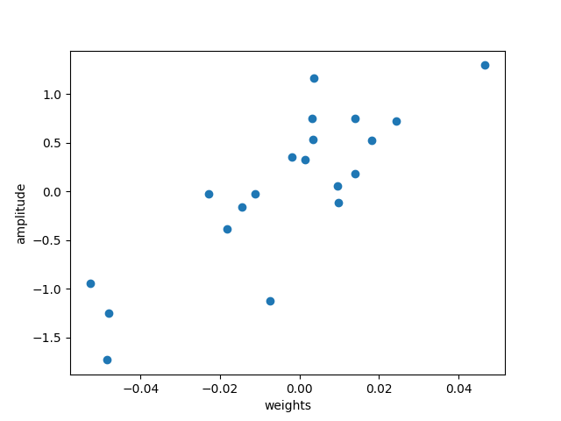

**2D: The Pearson’s correlation coefficient we calculated is 1.619844.**

**2E: Our r indicates a strong correlation, as r > 0.5**

**2F: The accuracy of this was roughly 55%**

**The accuracy of an SVM model gives confidence or support to the extent that it can accurately classify the data into the two categories of trials. A higher accuracy indicates that the SVM has learned to differentiate between the two categories of trials more effectively, whereas a lower accuracy indicates that the SVM is less able to differentiate between the two categories. However, it is important to note that the accuracy of the model alone may not be a reliable indicator of the model's ability to generalize to new data. Other factors, such as the diversity and balance of the training data, the complexity of the model, and the presence of overfitting, can also affect the model's performance. Therefore, it is important to consider these factors when interpreting the accuracy of an SVM model.**

## **Assignment 3 Representational Similarity Analysis**

**3A (figure):**

**3B:**

**3C (figure):**

**3D:**

**3E:**

## **Bonus Questions**

**Make sure to indicate which bonus question you answer (A, B, or C)**